**Software Testing**

**(Module – 1) Fundamental**

**Assignment –1**

**NAME: - Dhruvin Sathwara**

* **What is SDLC.**

SDLC stands for the Software Development Life Cycle.

It defines the process of how the software development works.

The goal of the SDLC is to produce software that meets customers all expectations and requirements.

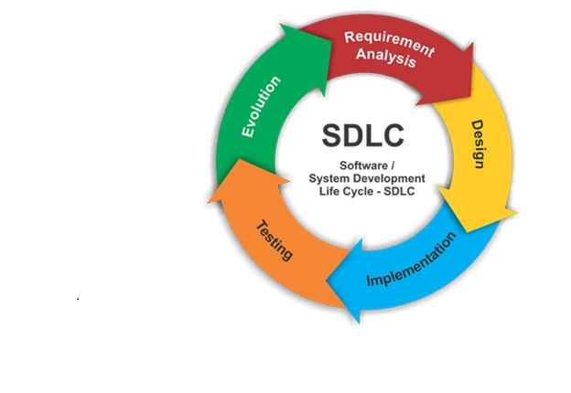

The SDLC defines different phases in which each phase

works by their own process.

The phases are as below: -

* Planning, Designing, Coding, Testing, Deployment.

In this cycle new phase starts after the completion of previous phase. As in this output of previous phase becomes the input for the next phase.

* **What is Software Testing**

Software Testing is a process of executing a system in order to detect any Errors, Gaps, or Missing Requirement in contrast to the actual desired requirements.

We can say that the process of evaluating the system to find that whether it satisfies the actual requirements or not.

The goal of the software testing is to identify the correctness, completeness, and quality of developed software.

* **What is Agile Methodology**

Agile methodology is most used in today's companies.

Agile methodology is a method that breaks down projects into several phases, which known as Sprints.

Iterative approach is taken and working product is delivered after each iteration.

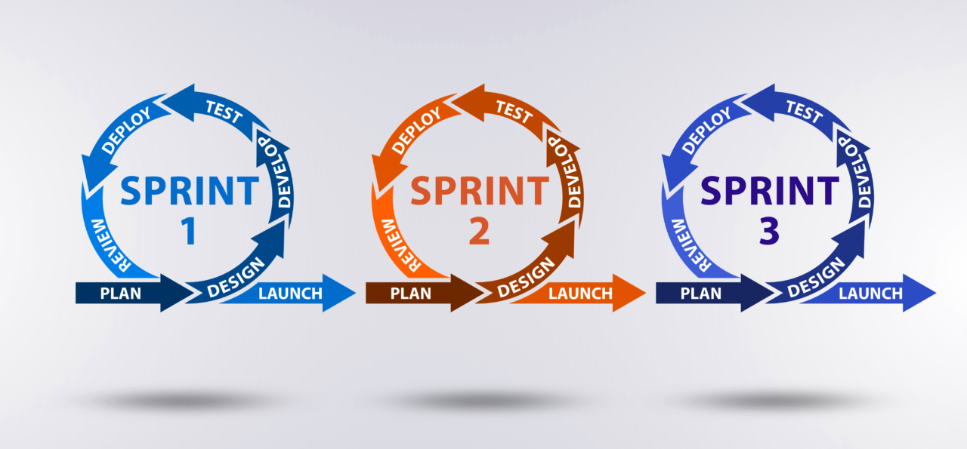

After every sprint team check and look back to see if there was anything that could be improved so they can adjust their strategy for the next sprint.

Each build is incremental in terms of the features and the final build holds the features which matches the client's requirements.

* **What is SRS.**

SRS stands for the Software Requirement Specification.

SRS is the document that describes what the software will do and how the software will perform. It is also called the Blueprint for the software that you are going to build.

SRS is a complete specification and description of requirements of the software that need to be fulfilled for the successful development of the software system.

* **What is OOPS.**

OOPS means the object oriented programming.

OOPS refers to the object based programming or language that uses object in programming.

In this, object is the real world entity.

It is a method for storing data and the operations required to process that data.

* **Write basic concepts of the OOPS.**

These are different concepts of the object oriented programming.

* 1. Object
  2. Class
  3. Encapsulation
  4. Inheritance
  5. Polymorphism
  6. Abstraction
* **What is Object.**

An objectis a basic unit of Object-Oriented Programming that represents real-life entities.

An object can be defined as a data field that has unique attributes and behaviour.

Object is made of the.

* 1. Data (properties)
  2. Function (behaviour)

Example: - Student

Data:- Name, roll no, Result

Functionality:- Insert data, Update, Delete.

* **What is Class**

We can say that Class is the Blueprint of the objects.

In the class we actually use the objects.

It describes the contents of the objects.

It defines a set of properties and methods of the objects.

Example: class named of Car. And its data and functions are the colour of car, four tire of car and drive method.

* **What is Encapsulation**

Encapsulation is the wrap the Data and Methods into the single unit. And unit here called the class. And Data and the Method of the object.

It enables the data hiding by binding the data and method of object into the single unit.

By doing this we prevent the other class to using its properties.

* **What is Inheritance**

The object of one class can acquire the properties of another class called the inheritance.

Inheritance means the data and methods of object for one class can also be used for another object for another class.

Super Class -> Sub Class

In this sub class can also use the properties of the super class.

* **What is Polymorphism**

It normally describes having many forms.

In OOPs by using this we can create the more than one function by using same name.

We can use the more than one function with the same names for different uses.

Ex: Sum (2+5)

Sum (abc + xyz).

* **Write SDLC phases with basic introduction**

Software Development Life Cycle (SDLC) is a framework that defines the phases involved in the development of software. It covers the detailed plan for building, deploying and maintaining the software.

SDLC has defined its phases as, Requirement gathering, Designing, Coding, Testing, and Deployment.

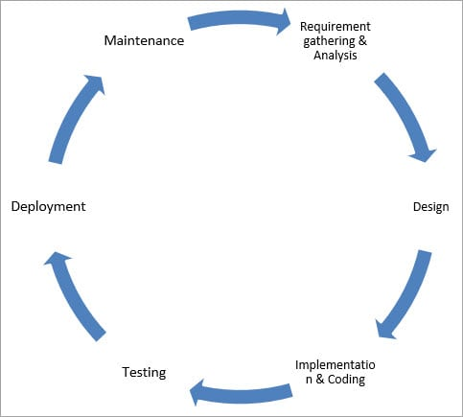

1. **Requirement gathering: -** During this phase all the required information is collected from the customer to develop a product as per their expectation.

The purpose of requirement gathering is to know what customer want to build, what is the purpose of the product.

1. **Design: -** In this phase, the software design is created, which includes the overall architecture of the software.

This phase shows the how the software will look and how it will work.

1. **Coding: -** Coding starts once the developer gets the Design document. The Software design is translated into source code by developer to develop the product.
2. **Testing: -** Once the coding is complete then Testing starts and the modules are released for testing. In this phase the developed product is tested to find that if there is any issue or defect in the product. And ensures that the desired requirements are match with the product.
3. **Deployment: -** Once the product testing is done and ensured that the product is developed as per client's expectations, it is delivered to the client for use.

* **Explain phases of the Waterfall Model**

The whole process of software development is divided into separate phases. One phase starts only after completion of the previous phase.

In this Waterfall model, the output of one phase becomes the input for the next phase.

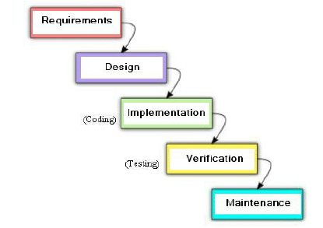

The phases are as below.

1. Requirement: - First phase of the model. In this phase all requirements are collected from the client in terms of develop the product. The requirement means what client wants in their product. Once the requirements are collected it will not change throughout the development of the product.
2. Design: -After requirements are collected from first phase then team starts the design phase of the product. In this phase the overall architecture of the product is created. The design phase shows that how the product will look or how it will function.
3. Coding: - In this phase developer starts the programming from the design phase. Developer writes the codes in terms of to create the product.
4. Testing: - Once developer competes the development of the project, it then comes to Testing phase to test the whole developed product. The product is tested to find any bugs or error if available and checked that it meets all the requirements that customer wants, because the requirements are static and cannot be changed.
5. Maintenance: - After all the phases are completed, the product is delivered to client. And to fix issues or errors that occurs on client side in future.

* **Write phase of Spiral model**

It is the combination of the Waterfall model and Iterative model. This model used for the risk management. The spiral model is used by software engineers and is favoured for large, expensive and complicated projects.

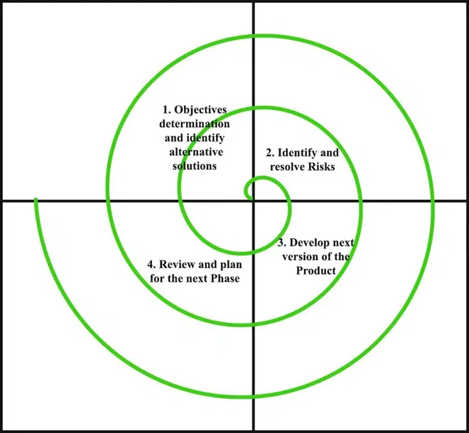

Phases are as below.

1. Discussion: - Each cycle in the spiral starts with the Discussion phase. In this phase we can start with the only concept of the project. We gather all business requirements for product in this phase by communication between client and developer team.

In this phase developer team also discuss and finals the system requirements will be used for development.

1. Risk analysis: - This phase includes the management of the risks. Risk analysis is to calculate the various types of the Risks based on the Goals. After the requirements are collected then the risky part of the project is identified with help of risk analysis and developed earlier. Analysis also done to estimate the cost.
2. Development of Objectives: - The development phase refers to production of the actual software product at every spiral. In this phase after each spiral the prototype of the product is created to get feedback from the client to saw that how the product will look. With requirements after each spiral number of builds are created and sent to customer to get feedback.
3. Next Iteration Planning: - This phase comes after the completion of the previous iteration and the project is reviewed. Then after the next iteration is planned for current project or to continue with the previous iteration to complete.

* **Write Agile Manifesto Principles**

The Agile Manifesto consists of four key values:

1. Individuals and Interaction: -

The more importance is given to the agile team members and individuals involved in project rather than on traditional process and tools or technologies.

Having the right group of individuals on your software team is vital to success.

The interactions between team members helps them to collaborate and solve any problems that arise.

1. Working software over comprehensive documentation: -

In the past, more focus used to be on proper documentation of every part of the project. But it consumes time and development process get delayed.

There comes a point when you should focus on providing your customers with working software. You can then gather feedback to help you improve future releases.

1. Customer Collaboration: -

Agile principles require customers to be involved in all phases of the project. This can help customer to easily track the process of the project. By doing this customer gives feedback over their product or required changes can be done by communicating with developer team.

While doing this team members can ensure that all the requirements meet of client to the final product and desired product can be deliver to the client.

1. Responding to the change: -

Before, the changes in the product roadmap were avoided by the maximum developers. sometimes customers demand extra features in the final product that may change the project scope. In these cases, project managers and their teams must adapt quickly in order to deliver a quality product and ensure 100% customer satisfaction.

* **Explain working methodology of agile model and also write pros and cons.**

Most used methodology in today.

Agile methodology means the project is divided into the small phases to continuous improvement for each phase.

As project is divided to multiple phases, for each phase team cycles through planning, evaluation, and execution stages.



After each phase the iterative approach is taken and working software is delivered after each iteration.

In this model first the requirements are gathered and according to them the working model is delivered to the client. In future if client needs some changes or new feature in their project, the project team will discuss on their requirements and then build will be created to work on it to meet the desired requirements and delivers the high-quality product.

Each build is incremental in terms of features and the final build holds the features which matches the requirements.

Pros: -

- Client can track the progress.

- Working and faster delivery of product.

- Any changes in the current product are acceptable.

- Issues fixed quickly before the next production cycle.

Cons: -

- Unclear requirement leads to delay in expected result.

- Less Documentation leads to confusion.

* - Due to changes in requirements the project becomes long.
* - Not suitable for short projects.
* **Draw use case diagram for online book shopping**

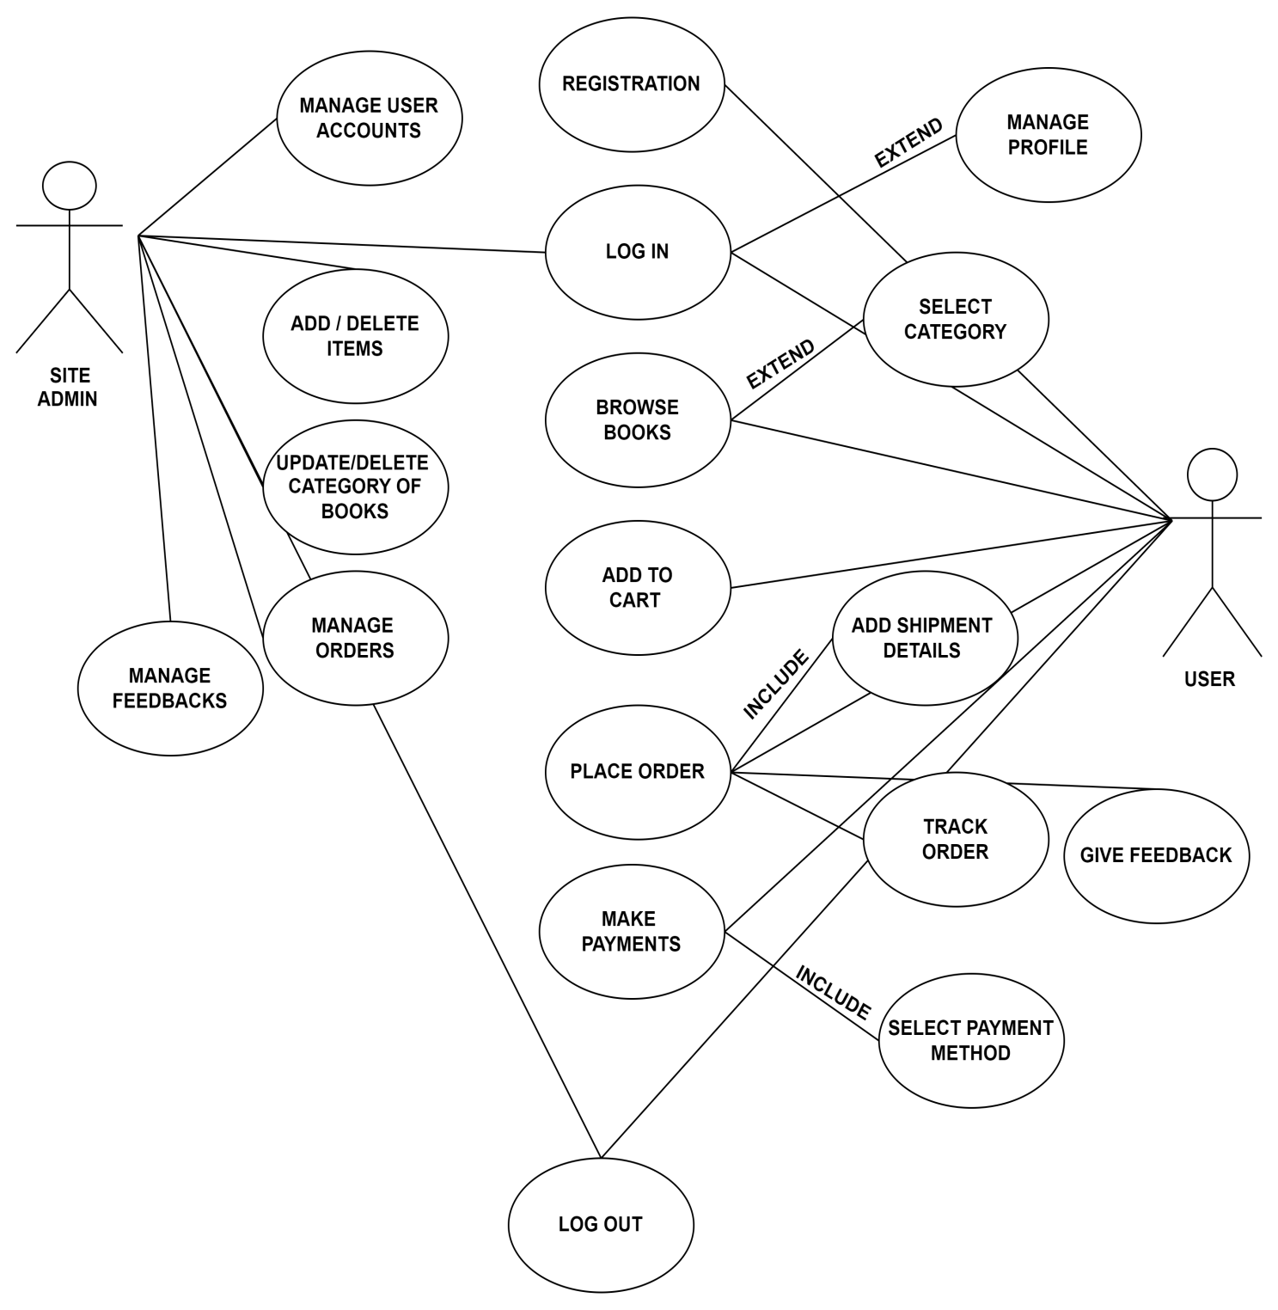

* **Draw use case on online shopping product using COD.**

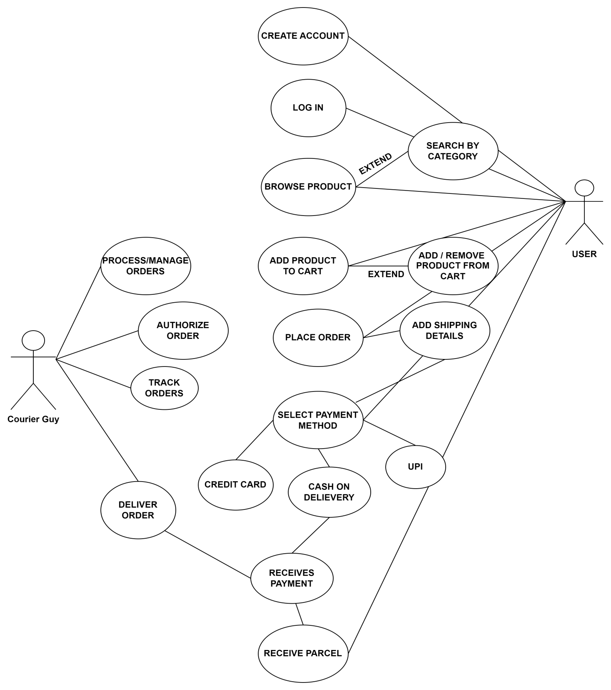

* **Draw use case on online bill payment system (paytm).**

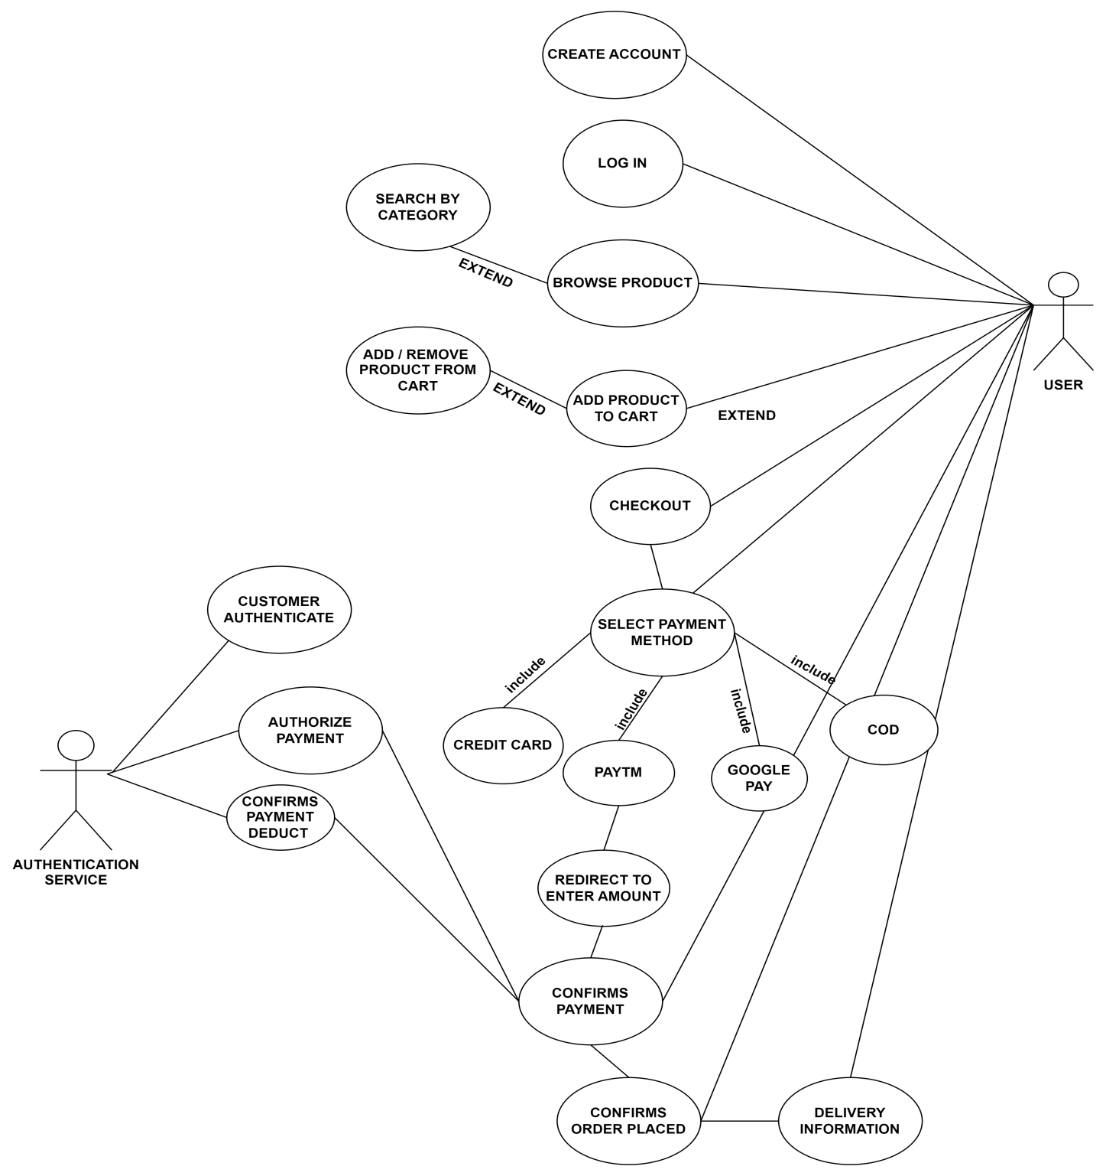

* **Draw use case on online shopping product using payment gateway.**

